MAY BANK HOLIDAY SHOW
At Wilsden Equestrian Centre
On Monday 31st May 2021
Working Hunter/Performance Ring (on Grass)
10am 1a Beginner Clear Round up to 30cm
10.30am 2a Lead Rein Working Hunter up to 30cm (snaffles only- riders 10 years and under)
11.15am 3a Very Novice Working Hunter up to 45cm (new to working hunter/jumping)
12am 4a Clear Round 55cm
12.30am 5a Novice Working Hunter up to 60cm
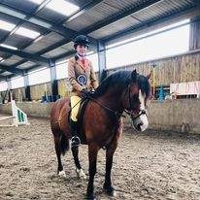
1.15pm 6a Open Working Hunter up to 70cm
2pm 7a Lead Rein Handy Pony (snaffles only – riders 9 years and under)
2.30pm 8a Beginner Handy Pony (new to doing handy pony)
3pm 9a Novice Handy Pony/Horse (not to have been 1st/2nd place in handy pony)
3.30pm 10a Open Handy Pony/Horse
In Hand Classes (indoors)
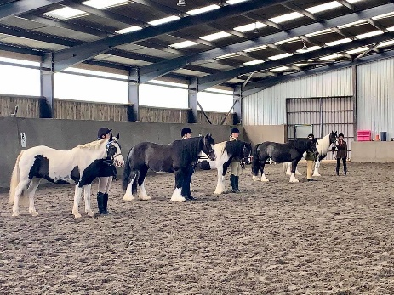
10am 1b Bonny Pony/Handsome Horse
10.20am 2b Junior Handler (12 years and under)
10.40am 3b Senior Handler (13 years and over)
11.00am 4b Coloured Horse or Pony any type
11.20am 5b Mountain & Moorland pure/part bred small and large breeds
11.40am 6b Cob (Native/Show), Riding Horse, Hunter (all over 14hh)
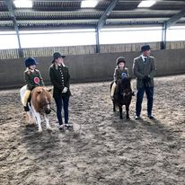
Ridden Classes (indoors)
12.30pm 7b Lead Rein Equitation (rider up to 8 years old, pony to be under 13hh) snaffles only
1.00pm 8b Junior Equitation (riders 12 years and under) snaffles only
1.30pm 9b Senior Equitation (riders 13 years and over) snaffles only
2.00pm 10b Coloured Horse or pony any type
2.30pm 11b Mountain & Moorland pure/part bred small and large breeds
3.00pm 12b Cob (Native/Show), Riding Horse, Hunter (all over 14hh)
3.30pm 13b Veteran horse or pony 16 years and over any type
All entries done via www.wec.lite.events – class sizes are limited; all times are approximate.

